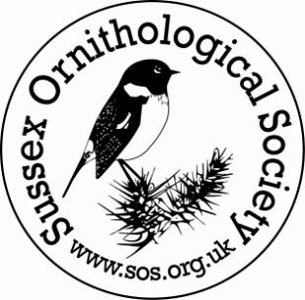
SOS Grant Application Form
Completed application forms should be e-mailed to Ted Merrikin, treasurer@sos.org.uk or mailed to SOS, Blessings, Barns Farm Lane, Storrington, West Sussex RH20 4AH.
Please note: monies will be paid upon receipt of invoice for materials or work done and supporting evidence of project completion.

The Objects of the SOS are:
To record and study wild birds in Sussex.
To assist in the preservation of wild birds in Great Britain.
To encourage by use of meetings, books, outings and other ways:
- The study of birds in the field and ornithological science in general.
- The education of its members and the general public in ornithological science in general.
- The need for protection of wild birds and their habitats.

Project name:

Contact name:

Telephone no:

Email address:

Name of site and location:

Brief description of project (max 500 words):

Summary of the experience, sources of information and evidence the applicant has drawn upon to give confidence that the project will succeed?

What is the total cost of your project and how have you arrived at this number? Please provide an itemised list of the main costs and provide assurance that for any large item over £1000, you are getting the best value:

Sum of money being requested from SOS:

How will your project support the objects of the SOS?

Are you providing any match funding towards this project? If so please give details:

Will the project have wider benefits?

How will the project/site be maintained in the future and who will do this?

Start and finish dates of the project (e.g. 12/04/2019-12/12/2019):

Additional information that would support your application?

