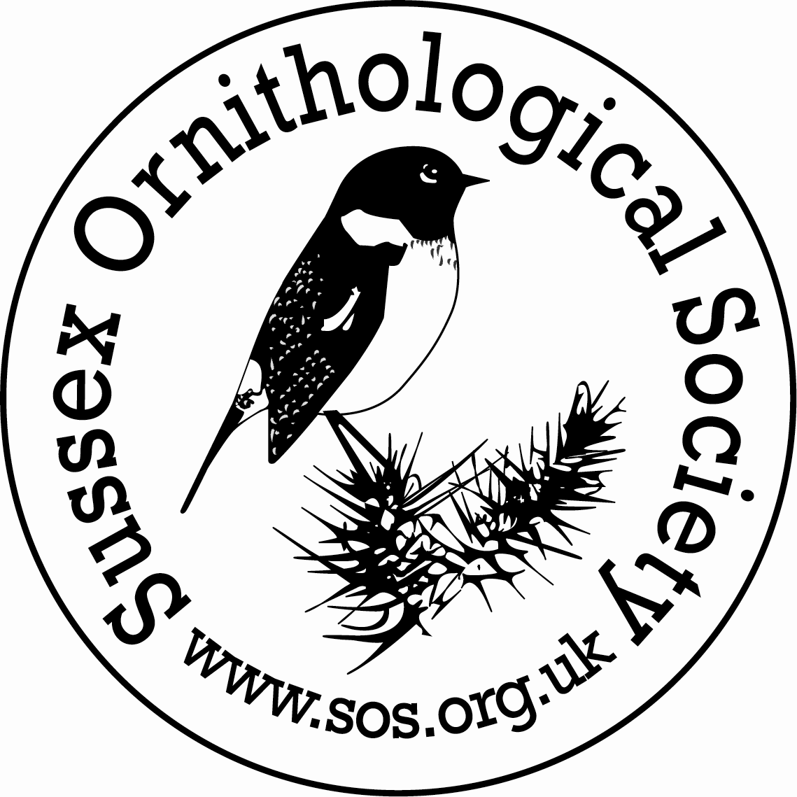 | Sussex Ornithological Society 41st Conference  Saturday 25th January 2020  Clair Hall, Perrymount Road, Haywards Heath, RH16 3DN  Registration and Coffee - 09.30am  Conference starts 10.30am and closes 4.15pm  The Conference is open to SOS Members only
Programme of Talks

Jane Smith Birds of the Hebrides – why islands are so good for wildlife
Wildlife Artist Jane Smith will share her experiences of the remarkable wildlife of the Hebrides. After a career as a wildlife filmmaker for the BBC and National Geographic Jane has settled in western Scotland. She chronicles the wildlife of the area through painting and print making. She has been a contributor to Radio 4’s Tweet of the Day and written a book called “Wild Island” about the RSPB’s work on Oronsay. Jane will talk about the birds of land and sea and her work as Artist in Residence for the Future of the Atlantic Marine Environment project and Project Puffin.
Lucy Groves White Storks Taking Flight – Reconnecting with a Wilder Britain
Lucy Groves is the White Stork Project Officer with Durrell Wildlife Conservation Trust and is based at the Knepp Rewilding project. The Project is led by a partnership of private landowners and nature conservation organisations, working together to restore a self-sustaining breeding population of White Storks in southern England by 2030 through a phased release programme over the next five years. She is responsible for much of the post-release monitoring including feeding ecology and movement data, andwill tell us about the project, its aims and successes so far, the ecology of the species, and the wider vision for the role of the White Storks in reconnecting people with nature.

Viola Ross-Smith Seabirds – A Conservation Priority
Dr Viola Ross-Smith is the Science Communication Manager at the British Trust for Ornithology. Viola began working on seabirds 15 years ago, when she embarked on a PhD on Lesser Black-backed Gull breeding ecology. She followed this with a 5-year stint as a research ecologist in BTO's Wetland and Marine Team, including high-profile work tracking gulls, skuas and petrels with GPS tags and geolocators. She is still involved in BTO seabird research, and edits Seabird, the journal of the Seabird Group. As well as being a public face of BTO science, Viola dedicates a lot of time during the summer months to improving the image of gulls in the media, by explaining the science behind their behaviour.

David Howey Splash Point Kittiwakes – A Scientific Study
Long-time SOS member David Howey has been carrying out surveys of the Sussex colony of Kittiwakes on the chalk cliffs at Splash Point, Seaford. David was a founding member of the Northumberland and Tyneside Bird Club in 1958, and was Sussex County Bird Recorder for four years and also Assistant Recorder. He regularly contributes to the SOS Newsletter and has written five scientific articles for the Annual Bird Report. David will use data from his monitoring of the Splash Point colony and other sites to reveal the changing fortunes in breeding success of the Kittiwakes, and the various factors involved.
____________________________________________________________________________________________________

The conference fee of £10.00 includes coffee and biscuits on arrival and an ample ploughman's lunch. Vegetarian option available if pre-booked. The bar will be open at lunchtime. There will be time to browse displays and stalls on a variety of bird and conservation topics. Limited free parking at Clair Hall. Nearby station car park costs around £6.

Contacts and Enquiries
Bookings: Val Bentley 01273 494723 or chetsford@talk21.com Organiser: Tim Squire 07929 964421 or tfsquire@yahoo.co.uk

Please complete the form below and send to: SOS Conference, Lanacre, Blackgate Lane, Henfield, West Sussex, BN5 9HA or email a completed copy to chetsford@talk21.com

I wish to book places at £10 per member (non-members not eligible to apply).
I enclose payment of £ ………(Please make cheques payable to Sussex Ornithological Society)
I have made a bank transfer of £ …... (Please transfer to Barclays Account no: 50660663, Sort code: 20-12-75 quoting your name and CONF as reference)
I have the following special requirements (eg special seating, vegetarian or other dietary needs) ..........................................................................................................................................................................................................
Name(s) in capitals as you would like them on your conference badge: ……………………………………………………………………………………
Address …………………………………………………………………………………………………………………………………………………………………………………….
......................................................................................... Tel no ………………………………………………………………………………………………
Email address ………………………………………………………………………………………………..
Please tick if: you would consider helping out at Conference in some capacity _________ this is your first SOS Conference
Bookings are confirmed by email but if you require acknowledgement by post please enclose SAE

